Solution Hints: VIEWS

13-1)

|  |  |
| --- | --- |
| **Key Words to Use:** | CREATE VIEW, SELECT, FROM |
| **Tables to Use:** | publisher |
| **Columns to Select:** | contact, phone |
| **Conditions to Specify:** | - |
| **Suggestions:** | - |

Sample output:

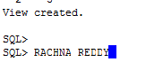

13-2)

|  |  |
| --- | --- |
| **Key Words to Use:** | CREATE OR REPLACE VIEW, SELECT, FROM, WITH READ ONLY |
| **Tables to Use:** | publisher |
| **Columns to Select:** | contact, phone |
| **Conditions to Specify:** | - |
| **Suggestions:** | - |

Sample output:

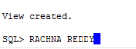

13-3)

|  |  |
| --- | --- |
| **Key Words to Use:** | CREATE FORCE VIEW, SELECT, FROM |
| **Tables to Use:** | firstattempt |
| **Columns to Select:** | col1, col2 |
| **Conditions to Specify:** | - |
| **Suggestions:** | - |

Sample output:

C:\Users\Vuyyuru\Desktop\314\CHAPTER 13\13-3.PNG

13-4)

|  |  |
| --- | --- |
| **Key Words to Use:** | DESC |
| **Tables to Use:** |  |
| **Columns to Select:** |  |
| **Conditions to Specify:** | - |
| **Suggestions:** | You need to describe homework13 |

Sample output:

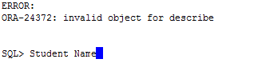

13-5)

|  |  |
| --- | --- |
| **Key Words to Use:** | CREATE VIEW, SELECT, FROM, JOIN, USING |
| **Tables to Use:** | books, publisher |
| **Columns to Select:** | isbn, title, contact, phone |
| **Conditions to Specify:** | - |
| **Suggestions:** |  |

Sample output:

C:\Users\Vuyyuru\Desktop\314\CHAPTER 13\13-5.PNG

13-6)

|  |  |
| --- | --- |
| **Key Words to Use:** | UPDATE, SET, WHERE |
| **Tables to Use:** |  |
| **Columns to Select:** |  |
| **Conditions to Specify:** |  |
| **Suggestions:** |  |

Sample output:

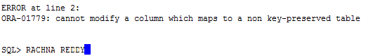

13-7)

|  |  |
| --- | --- |
| **Key Words to Use:** | UPDATE, SET, WHERE |
| **Tables to Use:** |  |
| **Columns to Select:** |  |
| **Conditions to Specify:** |  |
| **Suggestions:** |  |

Sample output:

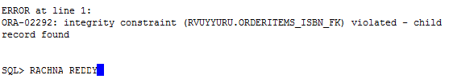

13-8)

|  |  |
| --- | --- |
| **Key Words to Use:** | DELETE FROM |
| **Tables to Use:** |  |
| **Columns to Select:** |  |
| **Conditions to Specify:** |  |
| **Suggestions:** |  |

Sample output:

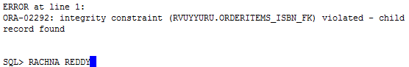

13-9)

|  |  |
| --- | --- |
| **Key Words to Use:** | ROLLBACK |
| **Tables to Use:** | - |
| **Columns to Select:** | - |
| **Conditions to Specify:** | - |
| **Suggestions:** | - |

Sample output:

C:\Users\Vuyyuru\Desktop\314\CHAPTER 13\13-9.PNG

13-10)

|  |  |
| --- | --- |
| **Key Words to Use:** | DROP VIEW |
| **Tables to Use:** | - |
| **Columns to Select:** | - |
| **Conditions to Specify:** | - |
| **Suggestions:** | - |

Sample output:

C:\Users\Vuyyuru\Desktop\314\CHAPTER 13\13-10.PNG